

*[Geochemistry, Geophysics, Geosystems]*

Supporting Information for

**PiAutoStage: An Open-Source 3D Printed Tool for the Automatic Collection of High-Resolution Microscope Imagery.**

R. Alex Steiner*, Tyrone O. Rooney

*Department of Earth and Environmental Sciences, Michigan State University, East Lansing, MI 48823, U.S.A.*

**Contents of this file**

Text S1 to S4

Figures S1 to S19

**Additional Supporting Information (Files uploaded separately)**

Captions for Tables S1 to S3

**Introduction**

This document contains information necessary for the construction and operation of the PiAutoStage system. Text supplements S1 and S2 detail the assembly and calibration of the system. Text supplements S3 and S4 contain the Arduino and Python codes required for motion and image capture. Figures S1-S3 contain full-section images of samples discussed in the main text. Figure S4-S16 are sequential images of PiAutoStage assembly that correspond to supplemental text S1. Table S1 details electronic components and tables S2 and S3 provide information on 3D printed components and parameters used during the printing process.

Text S1. - Assembly

1. Insert the Motors into the Stages
   1. Insert the micro servo motors into the housings on both the X-stage and the Y-stage.
   2. Press the horn that matches the recess in the gears into the center of the gears. Be sure that the horn seats fully into the recess.
   3. Using the screws included with each micro servo motor, fix the gear *with the recess down* to the motor axis (figures S1, S8, and S9).
   4. We have provided 1 and 2mm thick spacers that can be fit into the motor housings to adjust the spacing between the gears and the stage bottoms.
   5. First step is to initialize the servo motors, if you have not done so already. This will ensure that the neutral position of the servo motors and the center markers on stage components line up.
      1. To initialize the motors, follow steps a-d in Test S2).
2. Stage Assembly - Mobile components
   1. Slide the Y-stage into the Y-rack until the teeth on the Y-rack mesh with those on the Y-motor gear (Figure S1).
   2. Align the marker notches on the Y-rack and Y-stage (figure S2, figure S15).
   3. When fitting the Y-rack into place, tabs on the Y-stage will need to be trimmed for the Y-rack to fit between the two motor housings (figure S15). Use a utility knife and sandpaper to slowly remove material until the Y-rack fits between the motor housings. The Y-rack should slide freely, but not move side-to-side when the Y-stage is fully seated onto the X-stage.
   4. Fit the rectangular space on the Y-stage onto the X-motor housing on the X-Stage (figure S3).
   5. Slide the Y-stage onto the X-motor housing until the two posts on the X-stage fit into the corresponding holes on the Y-stage ((figures S3 and S4., ASSEMBLY2b).
   6. Press the Y-stage down until the Y-rack just touches the platform of the X-stage. Check that the Y-rack slides easily but doesn’t move up and down.
3. Attaching the PiAutoStage to the Microscope

Fitting the X-stage into the X-rack: The X-stage is printed with “ears” on each corner. While the purpose of these is to prevent the corners of the print from warping upward, we have found them useful in fitting the sliding X-stage into the X-rack rails. Remove both “ears” from the front of the X-stage but leave the ones on the back. Using a razor and sandpaper, gradually remove the “ears” from the back of the X-stage until it fits easily between the rails but does not rotate between them. It should slide easily and smoothly along the rails of the X-rack. If there are any points where the stage binds, lightly sand those regions of the rails until the mechanism slides smoothly. We recommend rubbing a graphite pencil along the rails to help reduce friction.  

* 1. Attach the X-Rack to the microscope stage platform using one of the following:
     1. Use the provided 3D printed alignment pins that seat into the mortices on the stage bracket and a machine screw to fix the X-rack to the stage platform.
     2. Double sided tape can be used when a mechanical connection is not possible. Apply double sided tape to the bottom of the X-rack bracket and press onto the stage platform.
  2. With the X-rack attached to the platform, set the mobile components onto the rails in the X-rack (figure 10 and 11).
  3. Align the markings on the X-stage and X-rack to ensure maximum range of motion along the X-axis (figure 14)
  4. Attaching the slide carriage
  5. The slide carriage is hot glued onto the end of the Y-rack (FIGCARRAIGE1). The carriage is hot glued onto the Y-rack for two purposes: (1) it is much easier to make the base of the carriage co-planer with the stage platform, and (2) if the stage malfunctions the carriage will separate from the Y-rack, preventing the thin section or microscope from being damaged by abnormal movement of the machine.
  6. Apply a bead of hot glue to the carriage mast figures (figure 12-13) and place the carriage flat on the microscope stage platform.
  7. Wait 5 minutes for the glue to cool completely before moving the stage.
  8. After the glue cools, check that the carriage is flat to the platform and square to the Y-axis. Misaligned or detached carriages can be easily reattached. Peel the carriage off of the Y-rack, remove all adhesive, and reattach.

Text S2. - Supplement Stage Calibration

Stage calibration requires a functioning Raspberry Pi computer with an Arduino UNO board attached by USB. We have used a Raspberry Pi 4 with 4GB of RAM running the Raspbian Operating System to which a Raspberry Pi HQ camera was attached by ribbon cable per instructions accompanying the camera. The Spyder development environment and Arduino IDE are not pre-installed on a Raspberry Pi Raspbian OS and must be installed prior to use. It may be useful to install the Picamerax package at this time but it is not needed for stage calibration.

Calibration of the PiAutoStage is accomplished by iterating through stage positions until the effective limits of the stage are determined. The following procedure details calibration of the stage through the Python console in Spyder 3 but calibration can also be accomplished through the Serial Monitor with the Arduino IDE software.

* 1. Determine what COM Port the Arduino is attached to on the Raspberry Pi. This will replace COMPORTNAME below.
  2. From the Python console in Spyder 3 (Python 3.7 or above), import the serial library.
  3. Initialize the serial port from the console with the following:
     1. Import serial
     2. ser = serial.Serial('COMPORTNAME', 9600)
  4. Create a string variable: a = ‘55551500’
  5. Encode the variable ‘a’ : ser.write(a.encode())
  6. The servos are now initialized to the neutral position of ‘15001500’ and can now respond to movement commands.
  7. Iterate through a range of X (first for digits) and Y (last four digits) and record the limits of the system, changing the pulse rate by 50-100 µs with each iteration.
  8. Enter the limits of the stage into the Python code as x_ini, x_max, y_ini, y_max
  9. Enter the coordinates (e.g. “13001100”) for the desired focus position (focus_pos) and four image parameterization positions (a, b, c, and d)

Text S3. – Arduino Sketch

Arduino IDE Sketch for the operation of the PiAutoStage. Script is available from the GitHub Repository: https://zenodo.org/badge/latestdoi/333261932

// zoomkat 11-22-10 serial servo (2) test

// Steiner-Rooney 01-29-2021 added in GoCode command to attach servos.

// for writeMicroseconds, use a value like 1500

// for IDE 0019 and later

// Powering a servo from the arduino usually DOES NOT WORK.

// two servo setup with two servo commands

// send eight character string like 15001500 or 14501550

#include <Servo.h>

String readString, servo1, servo2;

Servo myservo1; // create servo object to control myservo1 (X-motor)

Servo myservo2; // create servo object to control myservo2 (Y-motor)

void setup() {

//initializes the servos to the neutral position. Prevents unwanted movement.

Serial.begin(9600);

myservo1.write(90);

delay(500);

myservo2.write(90);

delay(500);

}

void loop() {

while (Serial.available()) {

delay(10);

if (Serial.available() >0) {

char c = Serial.read(); //gets one byte from serial buffer

readString += c; //makes the string readString

}

}

if (readString.length() >0) {

//Serial.println(readString); //see what was received

// expect a string like 07002100 containing the two servo positions

servo1 = readString.substring(0, 4); //get the first four characters, X-motor command

servo2 = readString.substring(4, 8); //get the next four characters, Y-motor command

int n1; //declare as number

int n2; //declare as number

char carray1[6]; //magic needed to convert string to a number

servo1.toCharArray(carray1, sizeof(carray1));

n1 = atoi(carray1);

char carray2[6];

servo2.toCharArray(carray2, sizeof(carray2));

n2 = atoi(carray2);

if (n1 == 5555) { //looks for the GoCode to attach the servo motors

myservo1.attach(12); //the pin for the servo control. Pin corresponds to X-motor.

myservo2.attach(13); //the pin for the servo control. Pin corresponds to Y-motor.

n1 = 1500;

}

myservo1.write(n1); //set X-motor position

delay(500);

myservo2.write(n2); //set Y-motor position

readString="";

}

}

Text S4. – Python Code (Python 3.2 or better; Spyder 3)

Python script for the operation of the PiAutoStage. Script is available from the GitHub Repository: https://zenodo.org/badge/latestdoi/333261932

import serial, time, os

import picamerax as picamera

from fractions import Fraction

##################################################################

########################### USER INPUTS ##########################

##################################################################

## HOME POSITION ##

x_home = 1500

y_home = 1500

## NUMBER OF STEPS ALONG AXES ##

num_x = 19

num_y = 15

## STAGE LIMITS ##

x_ini = 850

x_max = 2000

y_ini = 980

y_max = 1600

## FOCUS POSITION ##

focus_pos = '13001200'

## four photo parameter positions ##

a = '11001100'

b = '17001100'

c = '17001300'

d = '11001300'

#### Set the ISO Value ####

isx = 50

#### Set Image Capture Resolution ####

res = (2028,1550)

## USE THESE SETTINGS TO ALLOW THE CAMERA TO AUTOMATICALLY SET PHOTO PARAMETERS ##

gx = 0

qx = 0

## OPTIONAL INPUT TO MANUALLY SET PHOTO PARAMETERS ##

## These are values that you can use to control the camera ##

#gx = (Fraction(263, 128), Fraction(705, 256))

#qx = int(20694)

## STARTING FILE NAME. RESULTANT IMAGES WILL HAVE FILENAME 1000.JPG ##

## FILE NAMES WILL COUNT UP UNTIL IMAGE SEQUNECE IS COMPLETE ##

count = 1000

##################################################################

####################### END OF USER INPUTS #######################

##################################################################

#### Initialize Serial Port and Baude Rate ####

ser = serial.Serial('/dev/ttyACM0', 9600)

print('\n\nSerial port intilized: 5 second delay for Arduino\n')

#### Gives the Arduino time to intitialize ####

time.sleep(4)

#### sends the GoCode to attach the Arduino Pins to the Servos ####

go = '55551500'

ser.write(go.encode())

time.sleep(1)

print('Arduino Ready for Instructions\n')

time.sleep(1)

## NUMBER OF STEPS AND STEP SIZE CALCUALTED ##

gridX = num_x + 1

gridY = num_y + 1

x_step = abs(int((x_max - x_ini) / num_x))

y_step = abs(int((y_max - y_ini) / num_y))

i = 0

## Creates a text file that photo parameters and image locations will be writen to ##

otp = open(os.path.join("photo parameters.txt"), "w")

otp.write("Number of columns/X steps: " + str(num_x+1)+ "\n")

otp.write("Number of rows/Y steps: " + str(num_y+1)+ "\n")

otp.write("Total number of photos: " + str((num_x+1)*(num_y+1))+ "\n")

print("Number of columns/X steps: " + str(num_x+1)+ "\n")

time.sleep(1)

print("Number of rows/Y steps: " + str(num_y+1)+ "\n")

time.sleep(1)

print("Total number of photos: " + str((num_x+1)*(num_y+1))+ "\n")

time.sleep(1)

######## FOCUS AND IMAGE PARAMETER SEQUENCE STARTS HERE ########

print('Beginning focus and image parameter sequence. \n')

print('Moving to focus position at: ' + focus_pos + "\n")

ser.write(focus_pos.encode())

with picamera.PiCamera() as camera:

camera.resolution = res

camera.iso = isx

camera.start_preview()

time.sleep(15)

q1 = camera.exposure_speed

g = camera.awb_gains

camera.stop_preview()

print("Focus exposure speed: " + str(q1) + "\n")

print("Focus AWB gains: " + str(g)+ "\n")

otp.write("Focus exposure speed: " + str(q1) + "\n")

otp.write("Focus AWB gains: " + str(g)+ "\n")

ser.write(a.encode())

time.sleep(1)

with picamera.PiCamera() as camera:

camera.resolution = res

print("Photo Resolution: " + str(camera.resolution)+ "\n")

camera.iso = isx

camera.start_preview()

time.sleep(2)

q2 = camera.exposure_speed

g1 = camera.awb_gains

camera.stop_preview()

print("Position 'a' exposure speed: " + str(q2)+ "\n")

print("Position 'a' AWB gains: " + str(g1)+ "\n")

otp.write("Position 'a' exposure speed: " + str(q2)+ "\n")

otp.write("Position 'a' AWB gains: " + str(g1)+ "\n")

ser.write(b.encode())

time.sleep(1)

with picamera.PiCamera() as camera:

camera.resolution = res

camera.iso = isx

camera.start_preview()

time.sleep(2)

q3 = camera.exposure_speed

g2 = camera.awb_gains

camera.stop_preview()

print("Position 'b' exposure speed: " + str(q3)+ "\n")

print("Position 'b' AWB gains: " + str(g2)+ "\n")

otp.write("Position 'b' exposure speed: " + str(q3)+ "\n")

otp.write("Position 'b' AWB gains: " + str(g2)+ "\n")

ser.write(c.encode())

time.sleep(1)

with picamera.PiCamera() as camera:

camera.resolution = res

camera.iso = isx

camera.start_preview()

time.sleep(2)

q4 = camera.exposure_speed

g3 = camera.awb_gains

camera.stop_preview()

print("Position 'c' exposure speed: " + str(q4)+ "\n")

print("Position 'c' AWB gains: " + str(g3)+ "\n")

otp.write("Position 'c' exposure speed: " + str(q4)+ "\n")

otp.write("Position 'c' AWB gains: " + str(g3)+ "\n")

ser.write(d.encode())

time.sleep(1)

with picamera.PiCamera() as camera:

camera.resolution = res

camera.iso = isx

camera.start_preview()

time.sleep(2)

q5 = camera.exposure_speed

g4 = camera.awb_gains

camera.stop_preview()

print("Position 'd' exposure speed: " + str(q5)+ "\n")

print("Position 'd' AWB gains: " + str(g4)+ "\n")

otp.write("Position 'd' exposure speed: " + str(q5)+ "\n")

otp.write("Position 'd' AWB gains: " + str(g4)+ "\n")

qout = [q1, q2, q3, q4, q5]

q=min(qout)

print(qout)

print(q)

otp.write("Min exposure speed set: " + str(q)+ "\n")

otp.write("Camera ISO value set: " + str(isx) + "\n")

print("Min exposure speed set: " + str(q)+ "\n")

print("Camera ISO value set: " + str(isx) + "\n")

###### IMAGE CAPTURE PARAMETERS ARE AUTOMATICALLY SET HERE ######

if qx == 0:

q = q

else:

q = qx

otp.write("WARNING! CAMERA SETTINGS OVERRIDE, exposure set to " + str(q)+ "\n")

if gx == 0:

g = g

else:

g = gx

otp.write("WARNING! CAMERA SETTINGS OVERRIDE, gains set to " + str(g)+ "\n")

###### IMAGE CAPTURE SEQUENCE STARTS HERE #####

print('\nBegin Photo Acquision \nNumber of photos being collected: '+ str((num_x+1)*(num_y+1)))

x1 = str(x_ini)

x = x_ini

time.sleep(0.5)

while i <= num_x:

print('\nImaging column: ' + str(i+1) + ' of ' + str(num_x+1))

y = y_max

j = 0

#### The following 7 lines bring the carraige beyong the area being imaged. ####

#### This allows for the stage to compensate for the limited slip in gears ####

#### depending on the print quality (degree of slip) and the limits of the ####

#### user's stage, the y1 value may need to be changed ####

if x < 1000:

x1 = '0' + str(x)

else:

x1 = str(x)

y1 = '1700'

coord1 = x1 + y1

ser.write(coord1.encode())

#### This loop steps carraige along the column, capturing images ####

while j <= num_y:

time.sleep(0.5)

if x < 1000:

x1 = '0' + str(x)

else:

x1 = str(x)

if y < 1000:

y1 = '0' + str(y)

else:

y1 = str(y)

coord1 = x1 + y1

#print(coord1)

otp.write("Location of picture " + str(count) + " is at X= " + str(x1) + " and Y= " + str(y1)+ "\n")

ser.write(coord1.encode())

with picamera.PiCamera() as camera:

camera.iso = isx

camera.resolution = res

time.sleep(1)

camera.shutter_speed = q

camera.exposure_mode = 'off'

camera.awb_mode = 'off'

camera.awb_gains = g

filename = str(count) + '.jpg'

camera.capture(filename)

count = count + 1

y = y - y_step

j = j + 1

x = x + x_step

i = i + 1

a = x_home

b = y_home

if a < 1000:

a1 = '0' + str(a)

else:

a1 = str(a)

if b < 1000:

b1 = '0' + str(b)

else:

b1 = str(b)

coord = a1 + b1

print(coord)

ser.write(coord.encode())

otp.close()

ser.close()

Under high magnification or in the event of spherical aberrations, it may be necessary to reduce the field of view collected by the camera. To do this, replace the image capture sequence in the Python code with the following:

with picamera.PiCamera() as camera:

camera.iso = isx

camera.resolution = res

time.sleep(1)

camera.shutter_speed = q

camera.exposure_mode = 'off'

camera.awb_mode = 'off'

camera.awb_gains = g

**camera.zoom = (0.05,0.05,0.9,0.9)**

filename = str(count) + '.jpg'

camera.capture(filename)

count = count + 1

The line in bold clips the image to a smaller field of view. The syntax for the command is as follows: the first two digits translate the image collection region right and up 5% of the maximum collection region. The second two digits are scaling factors that reduce the number of pixels collected in the vertical and horizontal directions by 90%. In the example above, we have reduced the region of the field of view to 90% of the maximum, and shifted the observation are 5% to the right and 5% up to keep the image centered. Determining the translation amount (the first two digits) is accomplished by:

$$Translation Shift=\frac{(1-Scaling Factor)}{2}$$

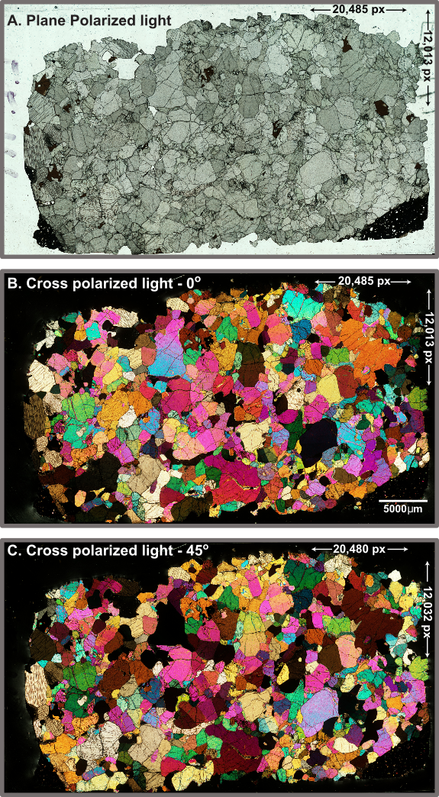

**Figure S1**. Three image mosaics of a mantle xenolith from Kilbourne Hole captured under three light conditions: (A) plane polarized light, (B) cross polarized light with the stage at 0° degrees, and (C) cross polarized light with the stage at 45° to the polarizers. Images A and B were stitched from images collected in the same orientation. Images comprising image C were collected 45° from presented orientation.

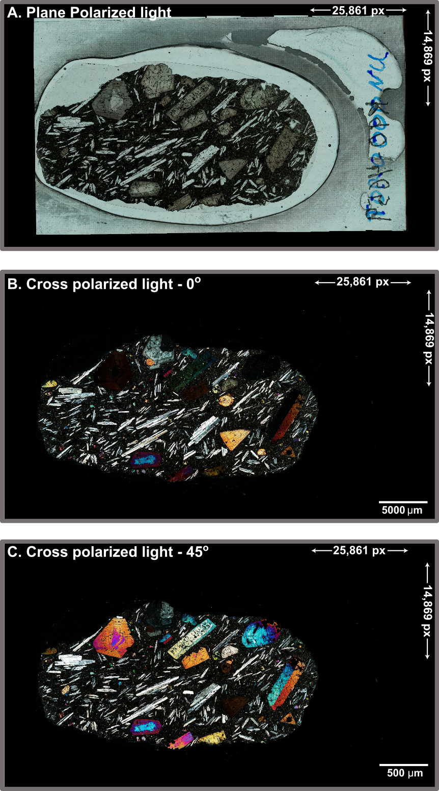

**Figure S2.** Three image mosaics of a porphyritic lava from the Nabwal Arangan beds in northern Kenya. A) plane polarized light, (B) cross polarized light and (C) cross polarized light with the stage at 45 degrees to the polarizers.

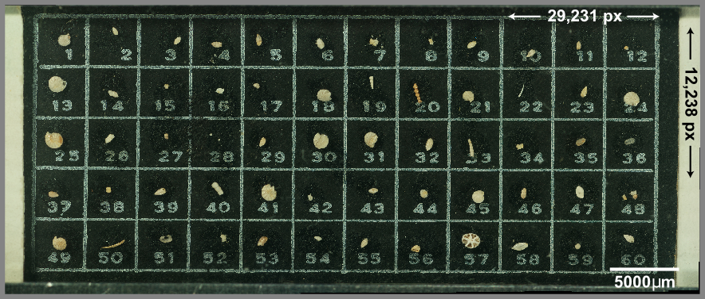

**Figure S3.** Image mosaic of a microfossil slide containing a variety of Eocene foraminifera.

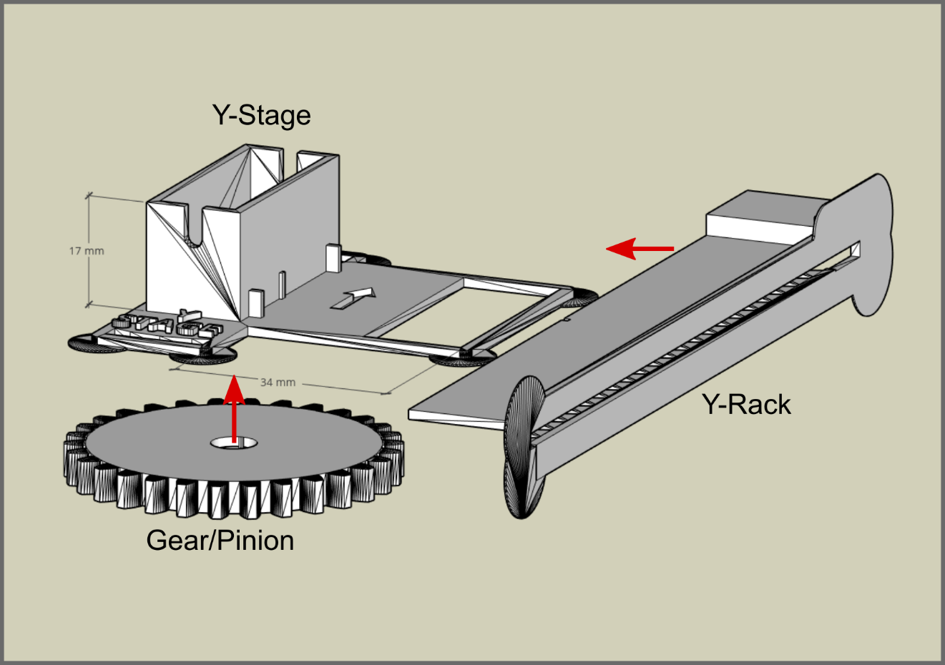

**Figure S4.**  Y-rack, Y-stage, and gear prior to assembly. Arrows indicate the direction the Y-rack slides over the Y-stage platform.

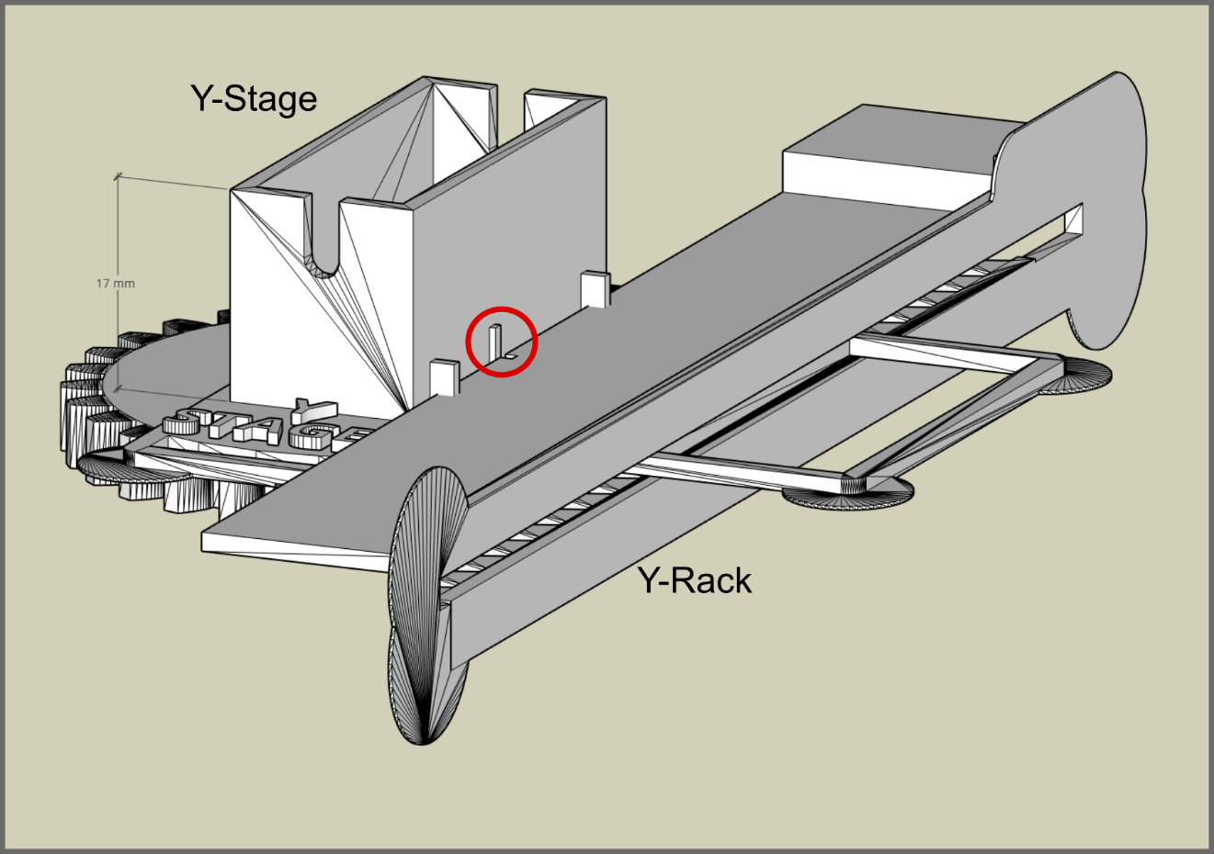

**Figure S5.** Assembled Y-rack, Y-stage, and gear.

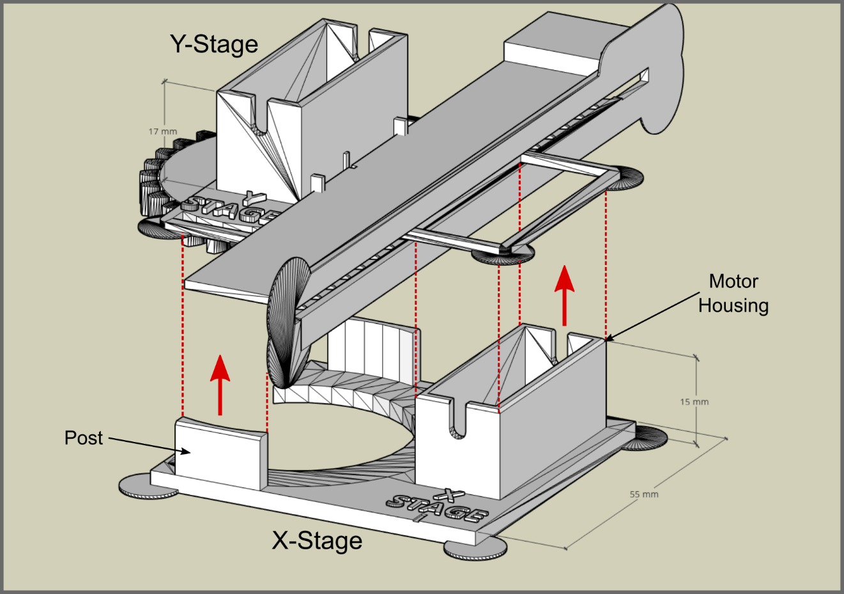

**Figure S6.** Y-stage and X-stage prior to assembly. Arrows and dashed lines indicate the assembly direction and orientation.

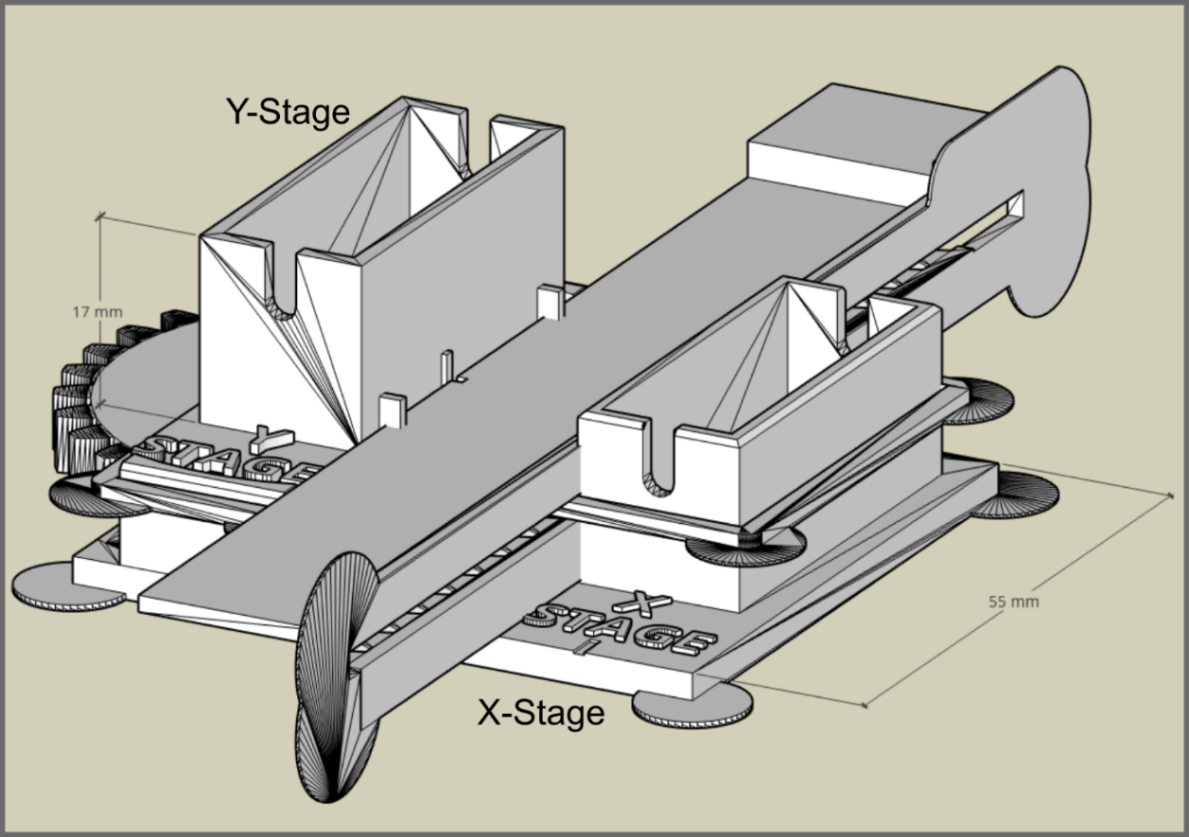

**Figure S7.** Assembled X and Y-stages. 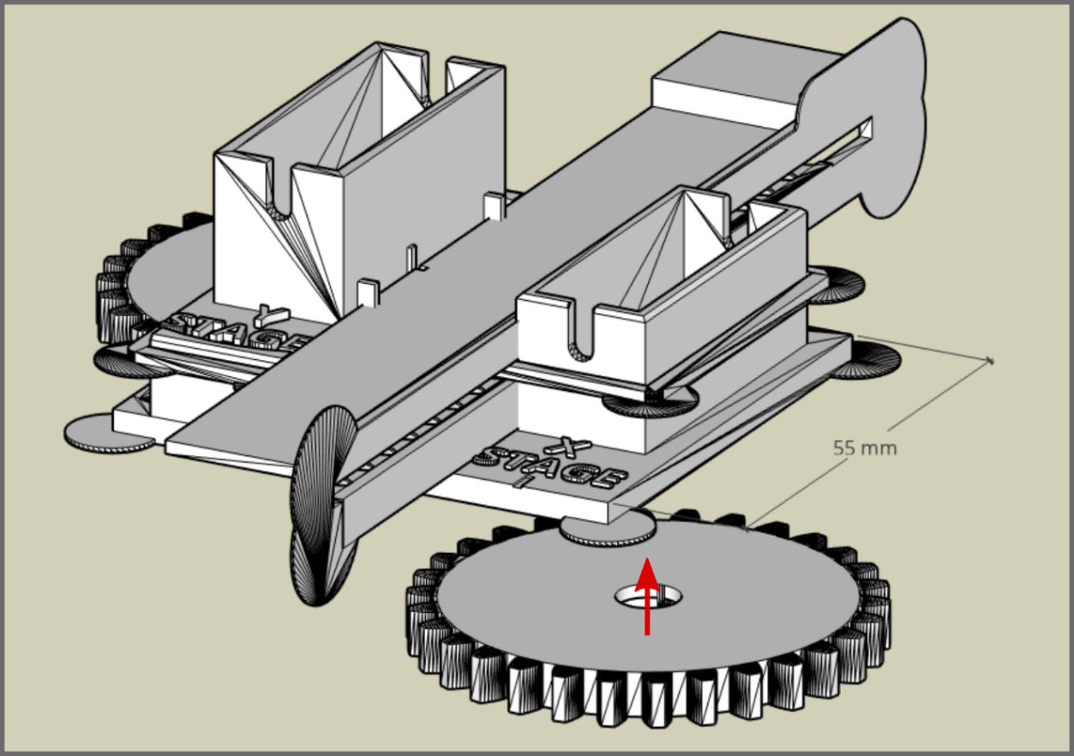

**Figure S8.** Fix the X-motor gear to the X-motor.

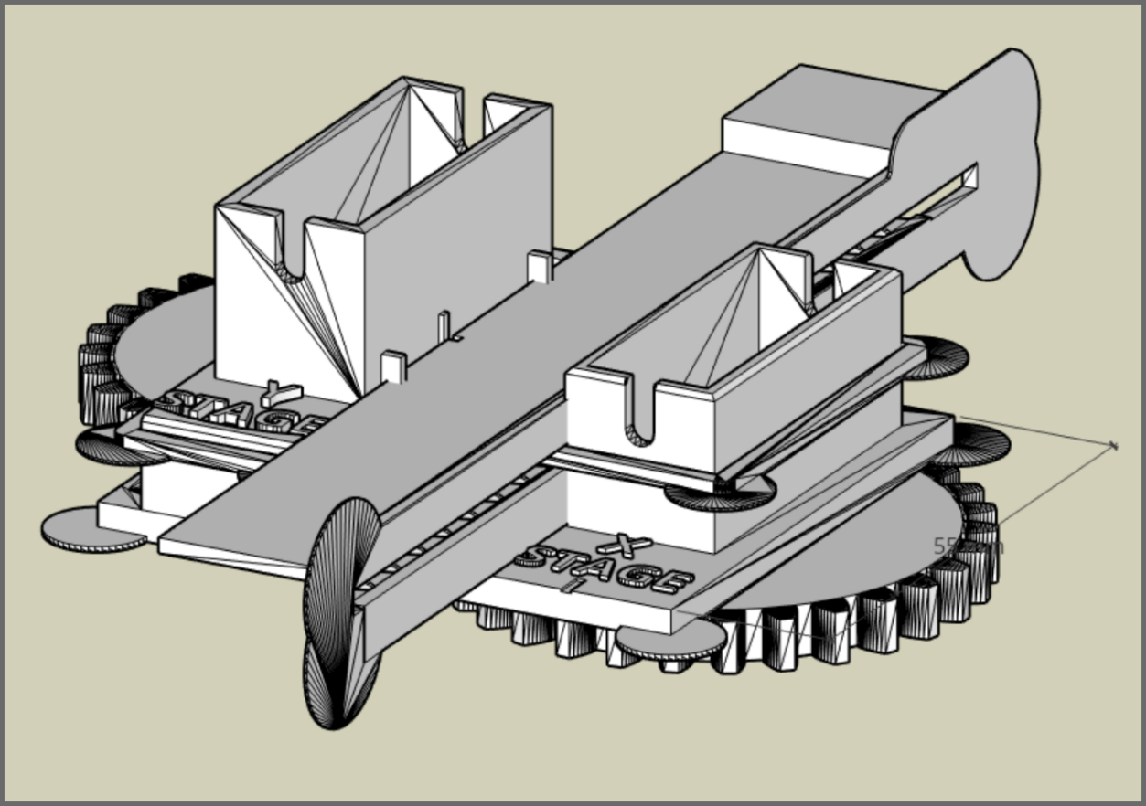

**Figure S9.** Fully assembled mobile components.

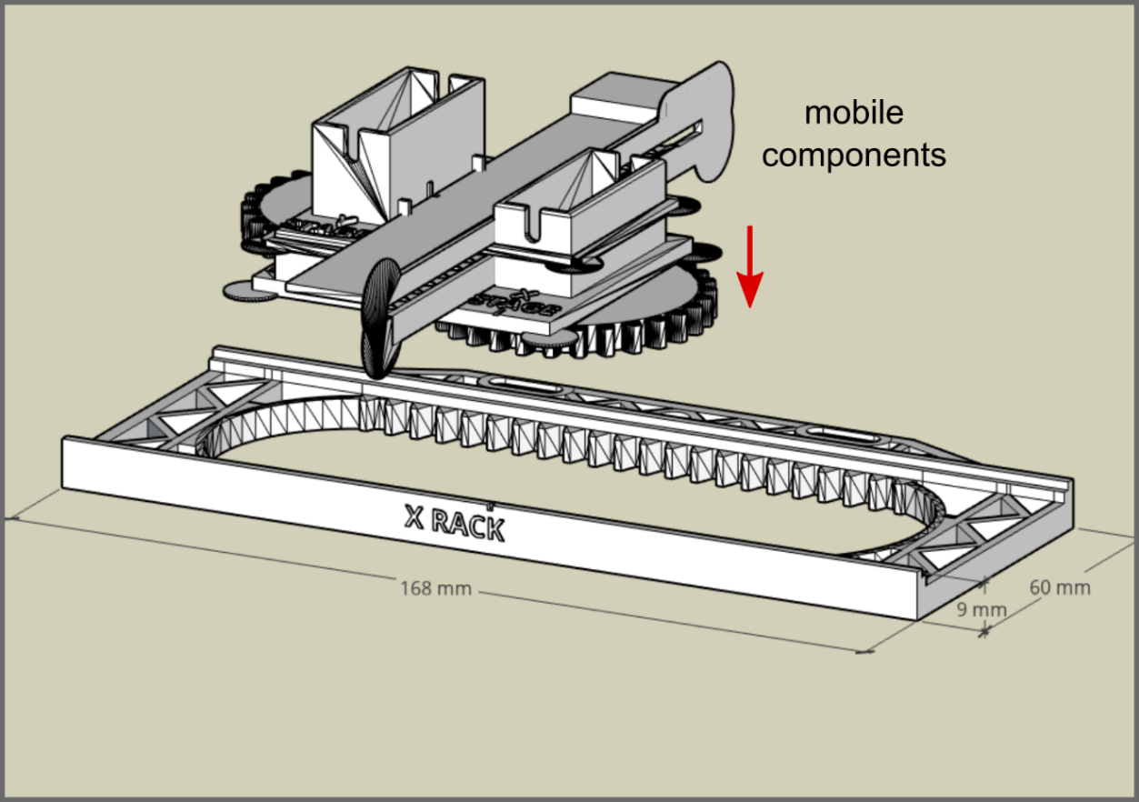

**Figure S10.** Mobile components ready to be set into the X-rack.

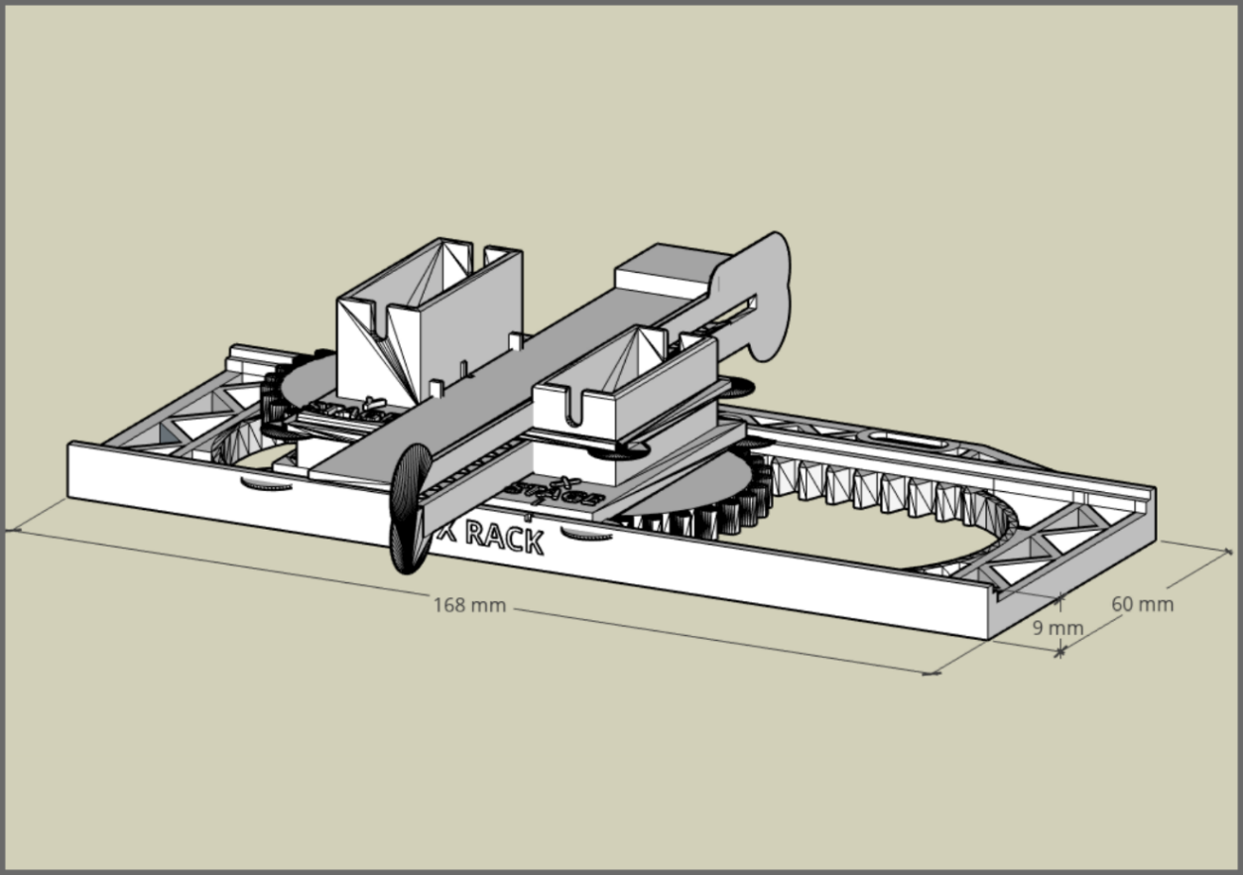

**Figure S11.** Mobile components set into the X-rack with the markings on the X-stage and rack aligned.

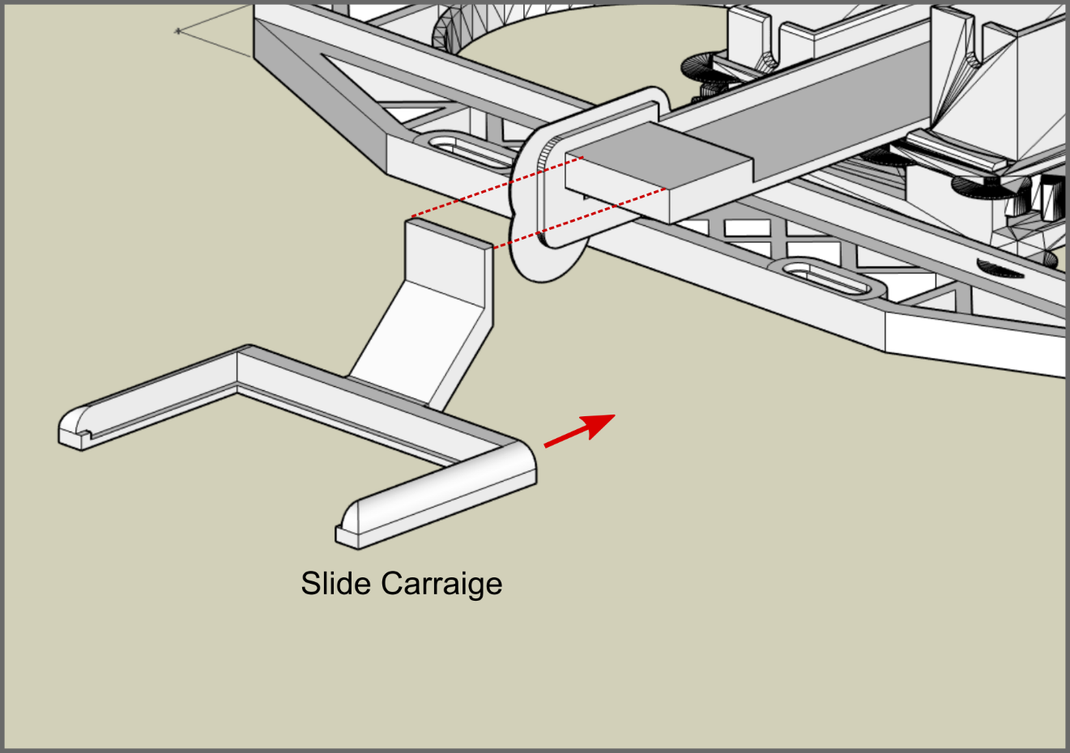

**Figure S12.** The slide carriage prepared to attach to the Y-rack. Vertical position of the carriage on the Y-rack may vary from the image.

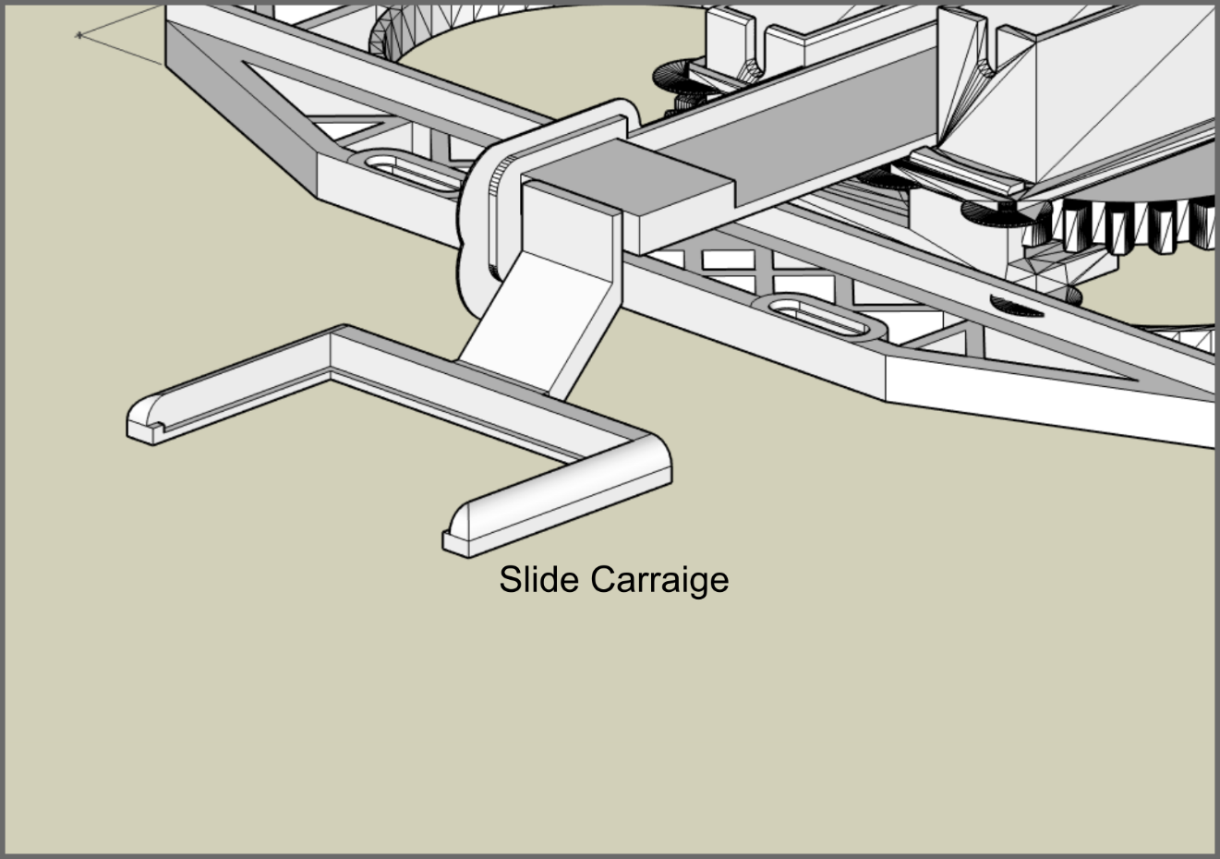

**Figure S13.** Slide carriage attached to the Y-rack. Vertical position of the carriage on the Y-rack may vary from the image.

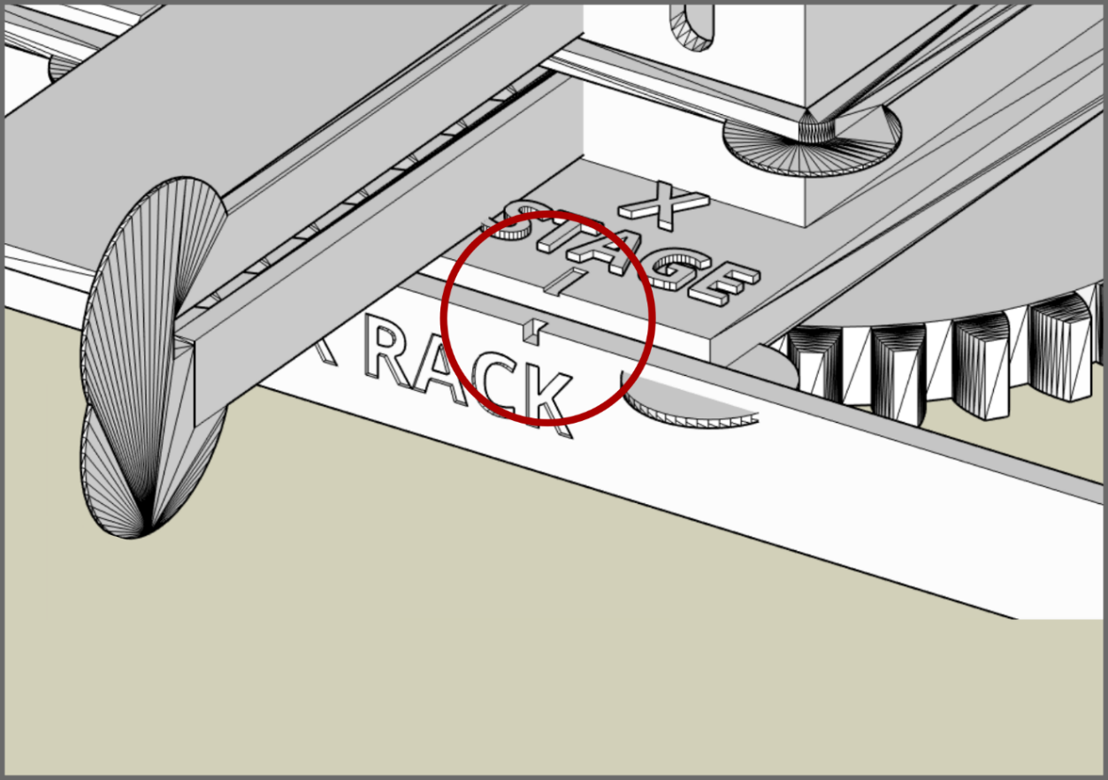

**Figure 14.** Markings (circled) on the X-stage and X-rack to aid in alignment of the components.

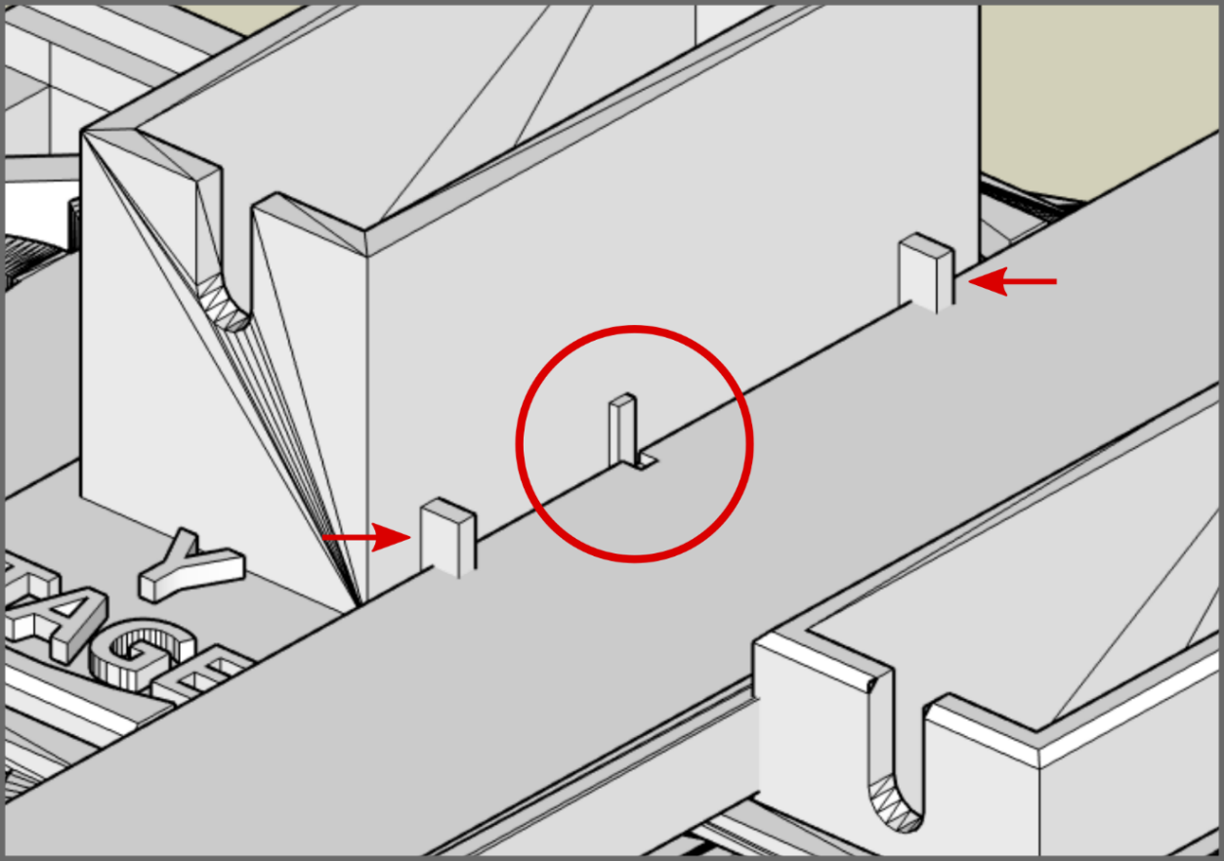

**Figure S15.**  Markings (circled) on the Y-stage and Y-rack to aid in alignment of the components. Arrows indicate tabs that are trimmed to aid in fitting the Y-rack.

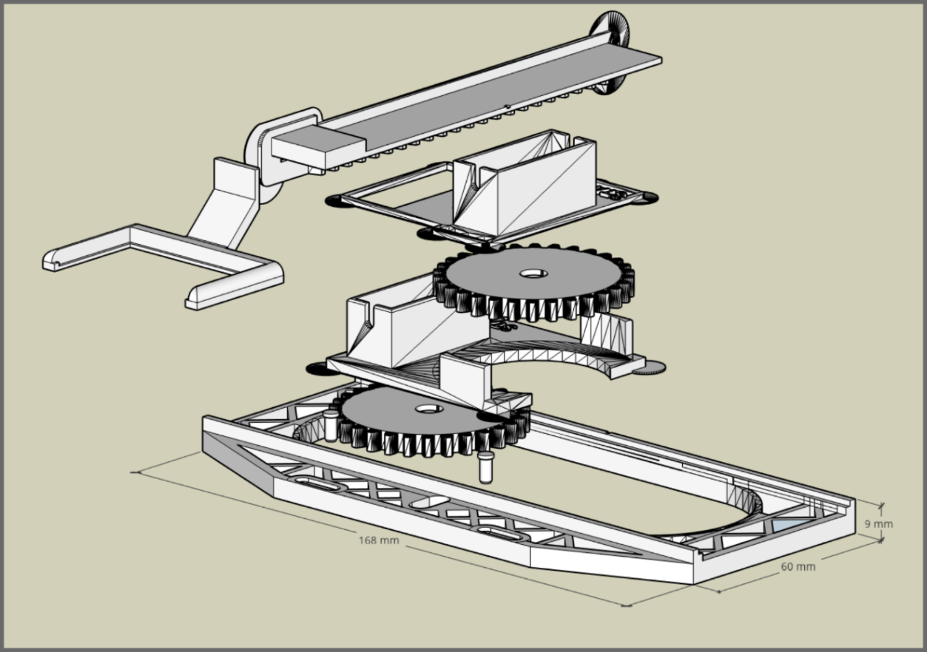

**Figure S16.** Exploded view of all 3D printed components to highlight the assembly sequence.

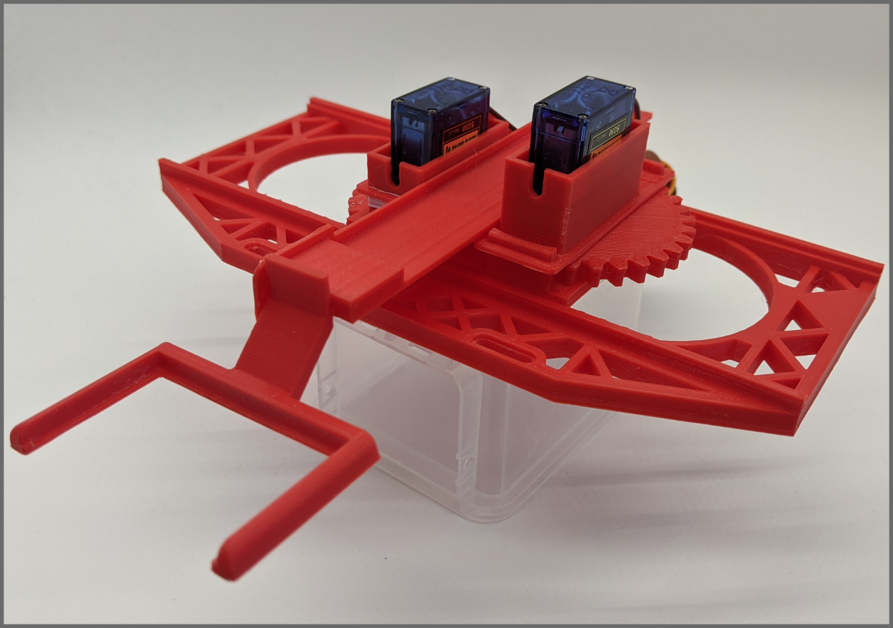

**Figure S17.** Picture of assembled printed components with servo motors in their housings.

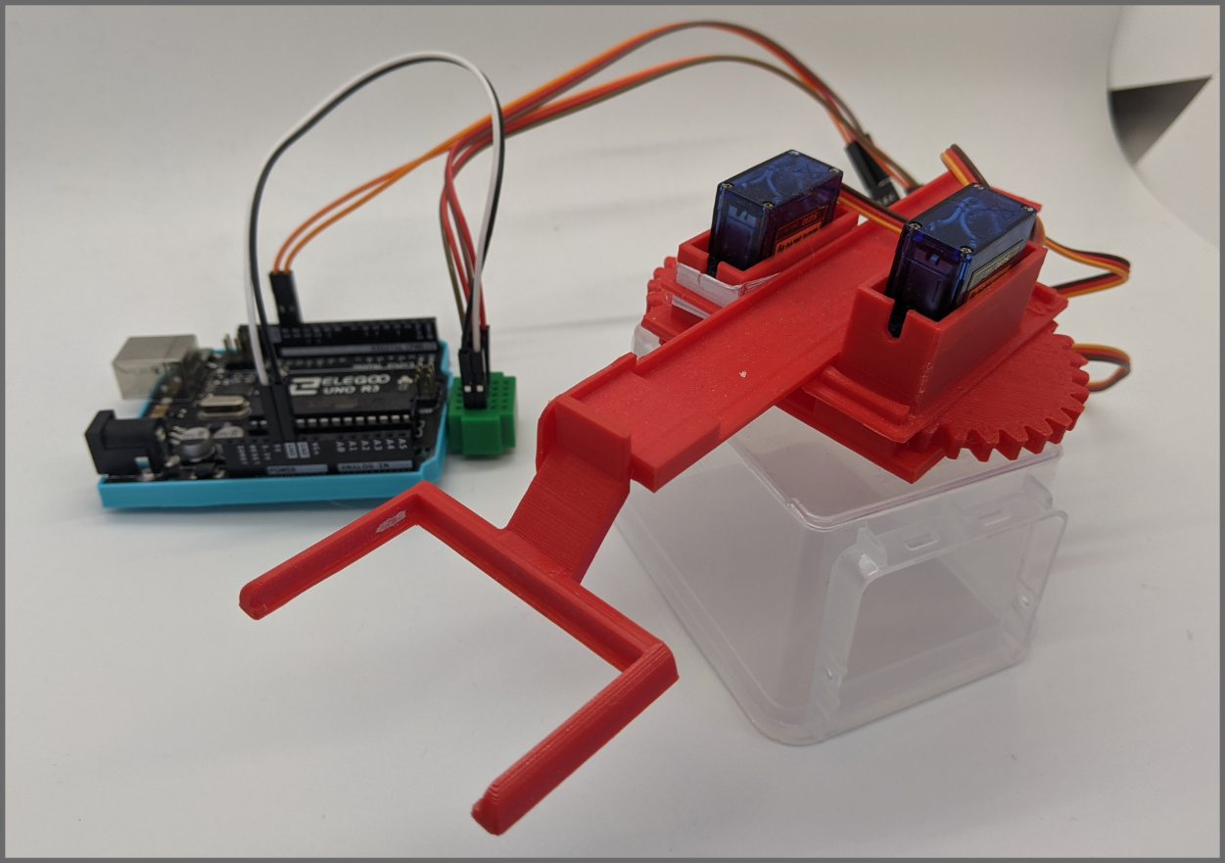**Figure S18.** Picture of the mobile assembly with servo motors in their housings and connected the microcontroller board. White Teflon tape was used to adjust a loose joint.

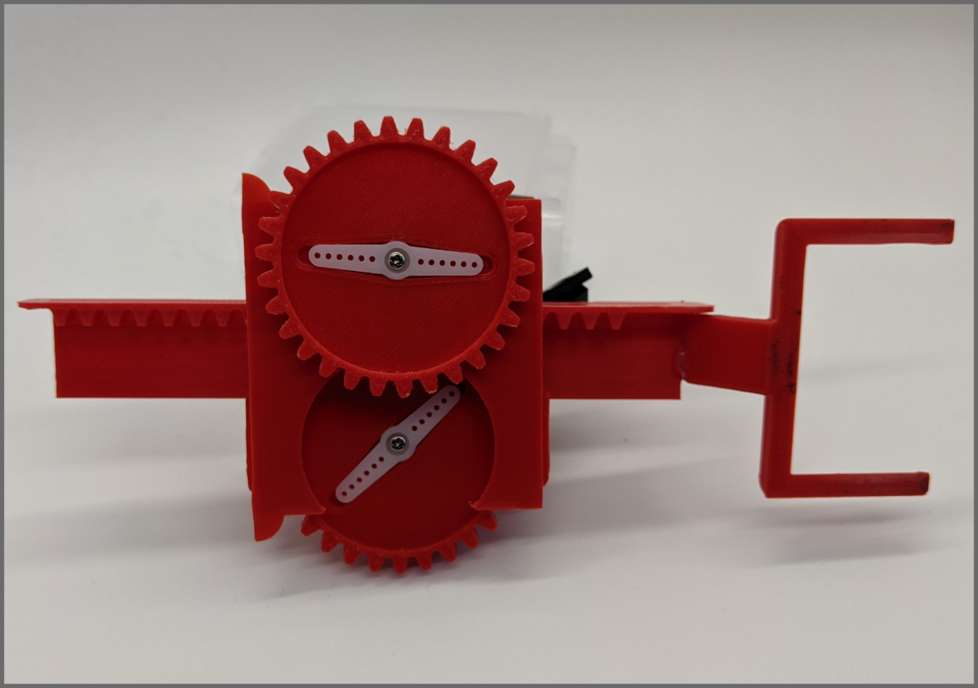

**Figure S19.** Picture of the underside of the mobile assembly with servo motors in their housings. White parts are “horns” included with most servo motors that fit into a recess on the bottom of the gears.

**Table S1.** Table of non-printed parts required for the construction of the PiAutoStage accompanied by product URLs.

**Table S2.** Table of 3D printed components including the number of copied needed. All 3D files can be downloaded from the PiAutoStage GitHub Repository.

**Table S3.** Table of printing parameters used to produce the PiAutoStage system.